Adam Mair
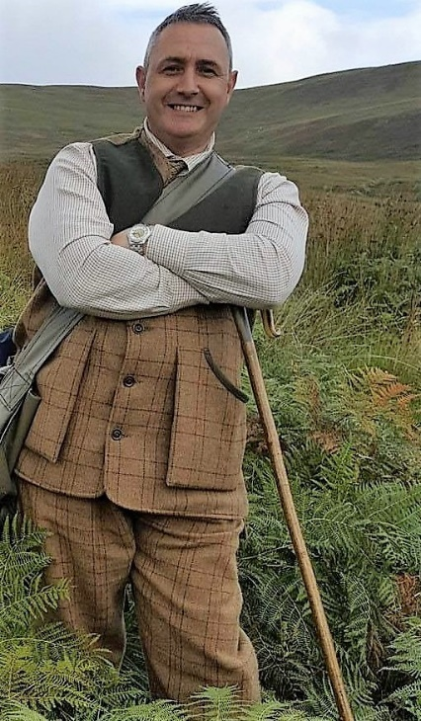
Professionally, I’m a design engineer, having worked in engineering since 1987.
I spent my longest time (22 years) as a senior engineer with a company who manufactured city cleaning equipment for the municipal industry sending machines all over the world – the brand known as “The green machine” can be found in many cities around the world as well as in Sweden.
I’ve been involved in field sports since I was a young child spending many days with ferrets and shooting rabbits with my father, then eventually having my own guns and shooting in syndicates and at dog trials. It was through shooting that I became interested in Labrador retrievers, having been fascinated by the way that they work.
I’ve successfully competed in working tests as well as field trials with Labrador retrievers and have two young dogs in my kennel for this coming season that are showing some positive potential at the moment.
Over the years I’ve served as a committee member on a few of the Scottish clubs and currently I’m the Field Trial Secretary for the Gamekeepers National Association – a club formed in 1907 which holds spaniel trials as well as a novice and an open qualifying retriever field trial in Scotland
I enjoy judging dogs as well as running them and have judged many tests and field trials both in Scotland and England and this year I’m happy to be asked to judge in the Czech Republic.
I’m delighted to be asked back to Sweden having judged a field trial there at the end of last year, it will be great to again meet people I now regard as friends. I also look forward to meeting new people and watching your dog’s work.
Adam.

