Tom Boyd
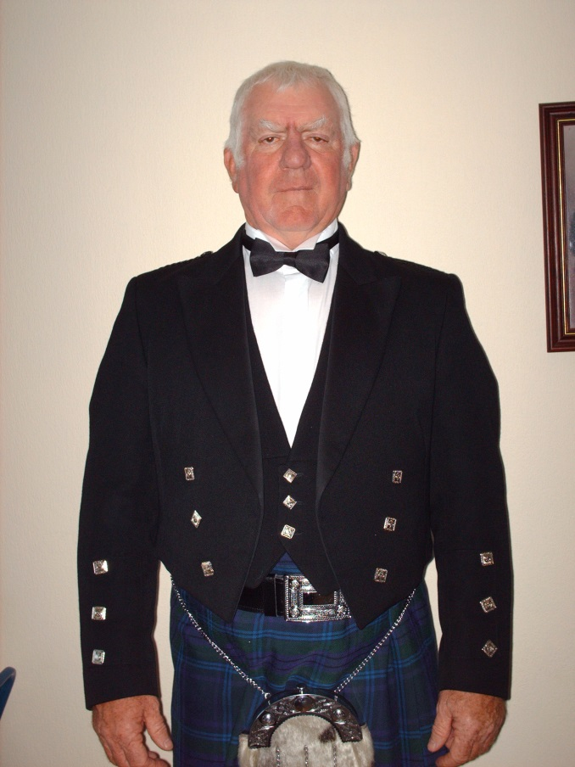
I have had labradors all my life, and an occasional spaniel. I was a gamekeeper for 40 years and was fortunate enough to be able to train my dogs as I worked. I have organised Trials and run my dogs in Trials for over 30 years and I have been an A-panel judge for over 25 years. I have judged all over the UK and the Continent and enjoy sharing my knowledge of dogs. Dogs from my breeding have had 1st and 2cnd place in the British Retriever Championships and I personally achieved 3rd place with one of my dogs. I have run dogs for Scotland on numerous occasions in National and International Tests. I look forward to judging in Sweden.

